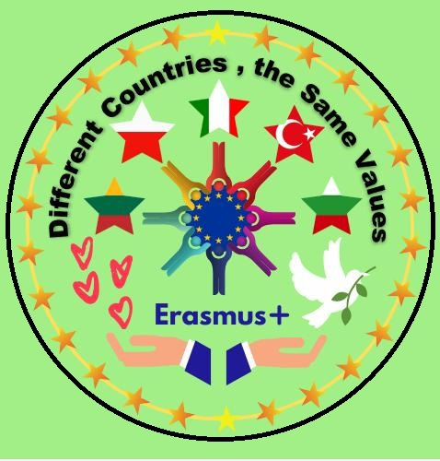
Lesson plan (Chemistry and English)
By Emilija Špokienė
Topic: | Homemade cleaners
Age: | 14 -15 years students
Time: | 45 min.
Competences: | To visualise for pupils how much and what kind of chemicals we use in daily life and propose to them non toxical clenears at home made bu themselves. To introduce them with homemade cleaners for everyday porpose.
Aim of this lesson: |  | To demonstrate how and for what we can make and use non toxical chemicals.
Introduction: | Understanding harmful and nonharmful cleaners.
Tools: | Computer, Internet, ingridients (Baking Soda, water, lemon, vinigar, salt)
Process
 | Step 1 | 5 min.
https://www.youtube.com/watch?v=7PJfpprBJy0
To work individually
Fill the separate in different colours papers with questions:
KNOW – blue colour (we know about non toxic or home made cleaners)
WANT- yellow colour (to learn about)
Teacher‘s notes (if needed)
 | Step 2 | 3 min.
To present the aim and plan of work during the lesson
To present the evaluation
To divide students in 4 groups of 3-4

Teacher‘s notes (if needed)
 | Step 3 | 2 min.
To present the ingridients that will be used in practical work:
Baking Soda, water, lemon, vinigar, salt.
To introduse students with the safety during their experiments.
Each group gets 3 papers with the instruction how to make cleaners
Gro
Teacher‘s notes (if needed)
 | Step 4 | 20 min.
Each group gets 3 papers with the instruction how to make cleaners.
Making cleaners
Teacher‘s notes (if needed)
 | Step 3 | 10 min.
Every group present one of the cleaner of three:
- What ingridients they use?
- How they did?
- For what this cleaner could be used?
Teacher‘s notes (if needed)
 | Step 4 | 5 min.
Rexlection:
Fill the separate in different colours papers with question:
LEARN (red colour): what each of them learn from this chemical practical tasks)
Evaluation of group job and short presentations.

Teacher‘s notes (if needed)

